Linear Regression:
Assumptions for Internet download speed prediction
Linearity test: compared all the i/p features with o/p to check the positive and negative relationships
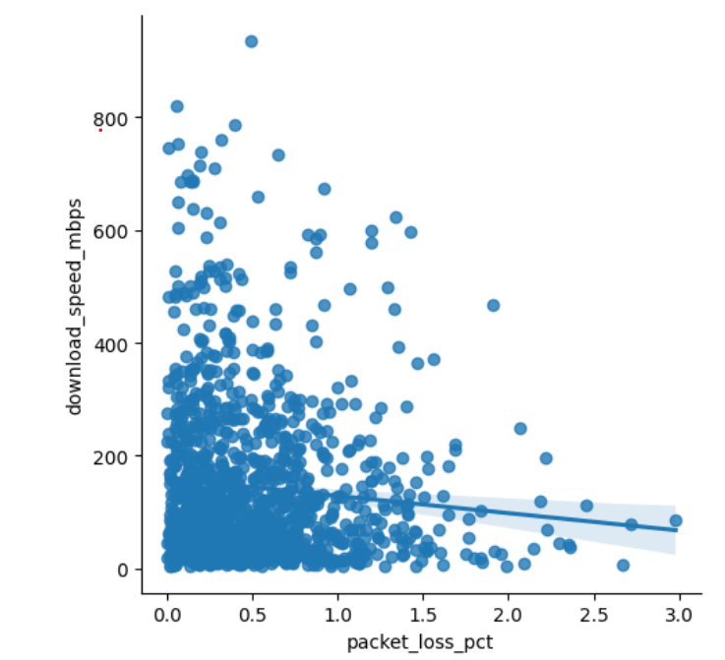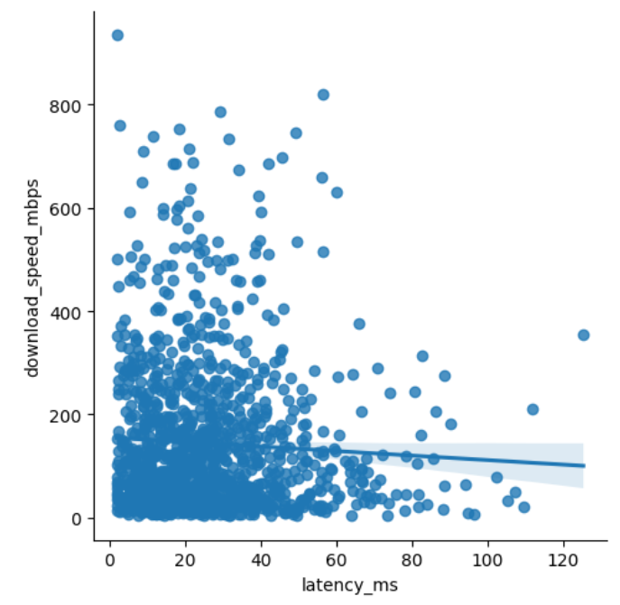
- Download speed Vs packet loss: Negative relationship i.e. when packet loss is high the download speeds tend to fall.
Highly scattered: With loss packet loss observed high download speeds as well as low download speeds
Linearity test: failed
- Download speed Vs latency: Negatively correlated (i.e.) when latency is low, we observe high download speeds and in high latency download speeds are less
Highly scattered: So, with low latency we see high download speeds as well as low download speeds
Linearity test: failed

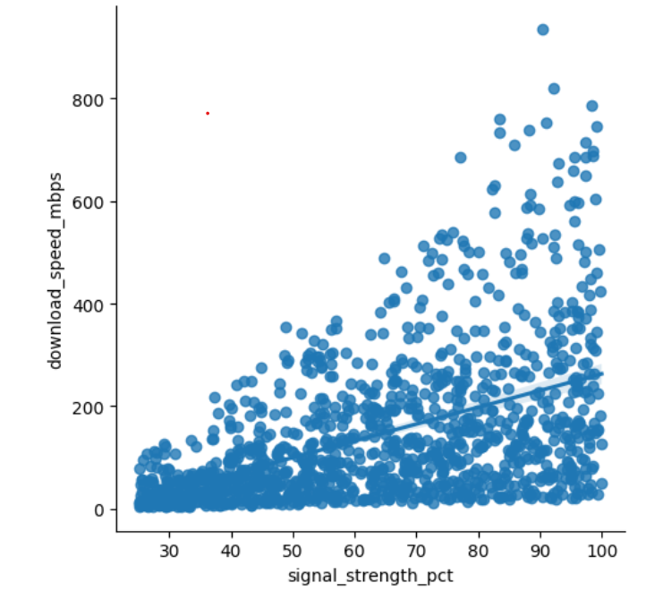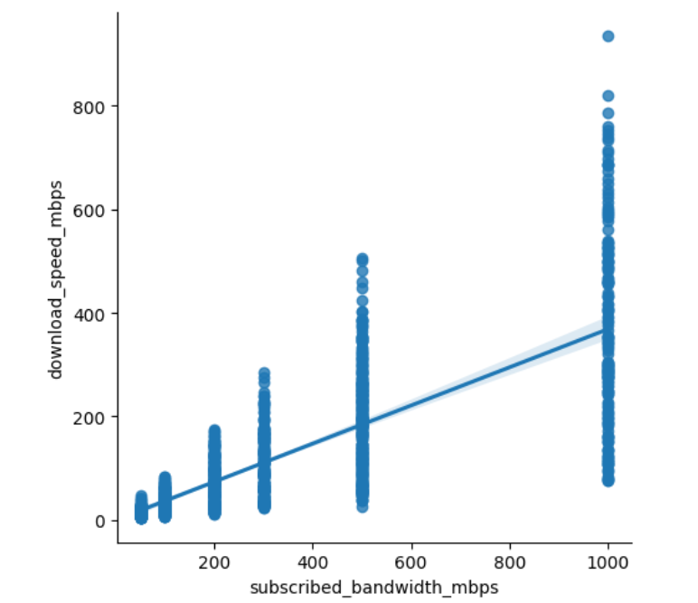

- Download speed Vs Signal strength: Positively correlated (i.e.) when signal strength increases download speed increases
Highly scattered at the same signal strength, could observe download speeds vary significantly
Linearity test: failed
- Download speed Vs subscribed bandwidth: Positively correlated (i.e.) when subscribed bandwidth increased download speed increased significantly

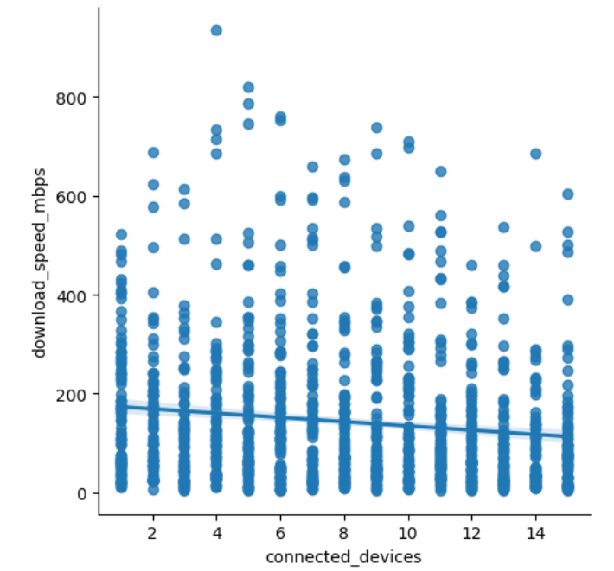
- Download speed Vs Connected devices: Negatively correlated (i.e.) when connected devices increases download speed decreases
Highly scattered at the same connected devices, could observe download speeds vary significantly
Linearity test: failed

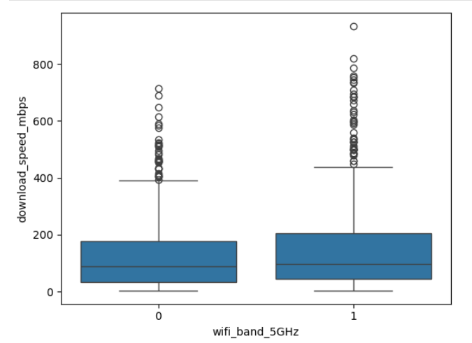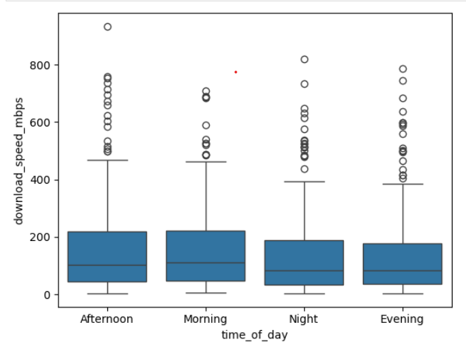

- Download speed Vs WIFI band: Positively correlated (i.e.) when WIFI band 5GHZ, download speed slightly increased. The median shows a slight increase when comparing with 2.5GHZ median
- Download speed Vs time of day: Morning and Afternoon appears slightly high download speed than evening and night
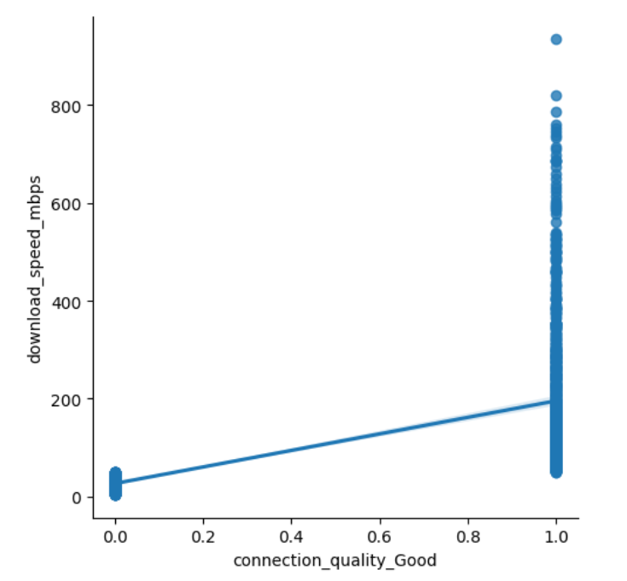
- Download speed Vs connection quality: Positively correlated, when connection quality is good, the download speeds are increased.
Highly scattered: when connection quality is good observed download speeds are both high and low
Connection quality is dependent on O/P feature (download speed) so cannot be a i/p feature

Test 2: normality test: Most values concentrated around the centre.
Normality test to check whether model prediction errors follow the normal distribution of data
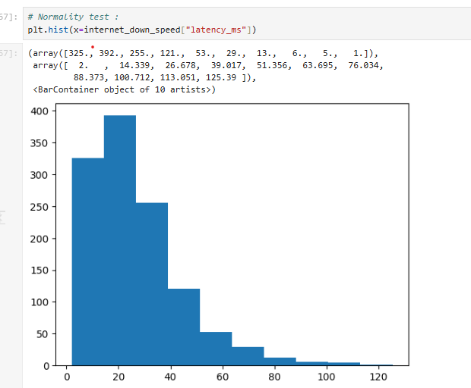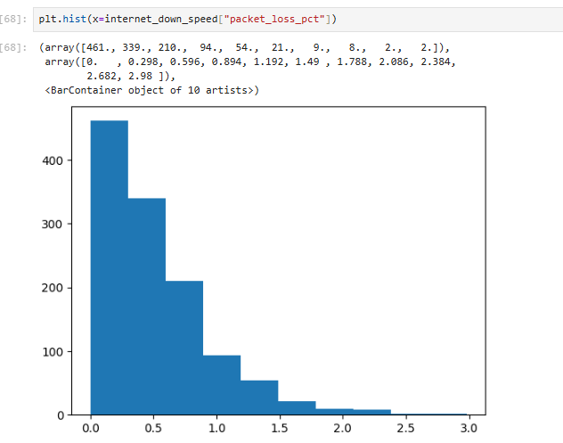

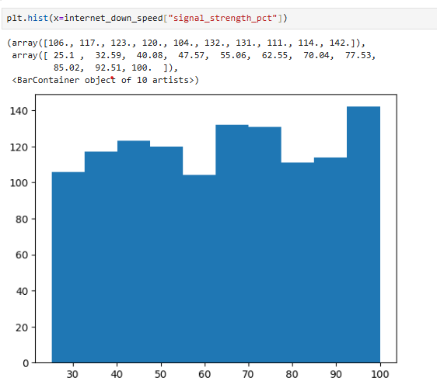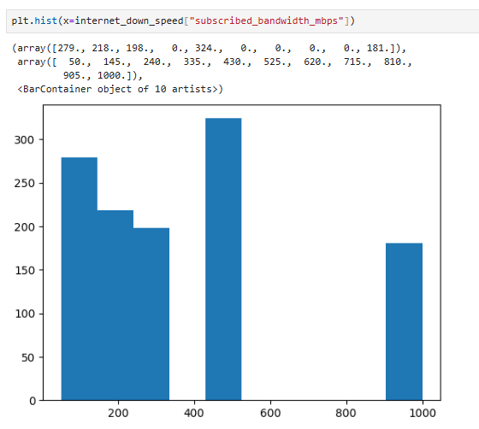

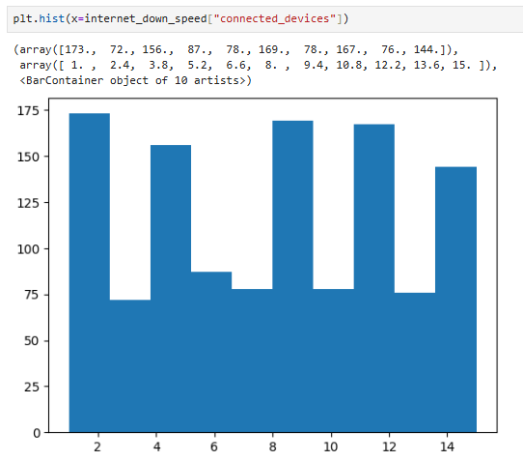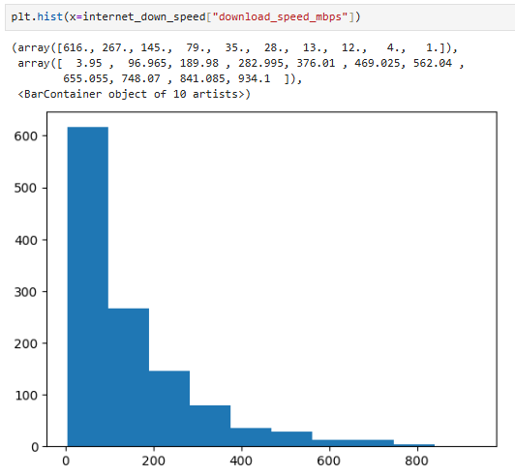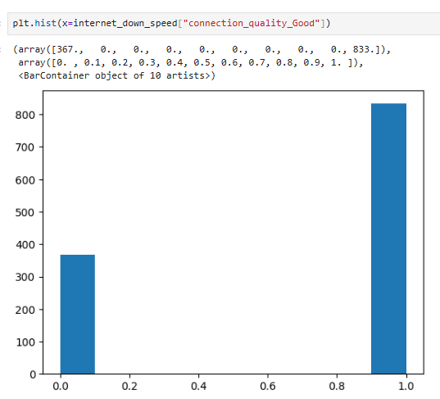
Normality test: failed

Test 3: Correlation matrix:

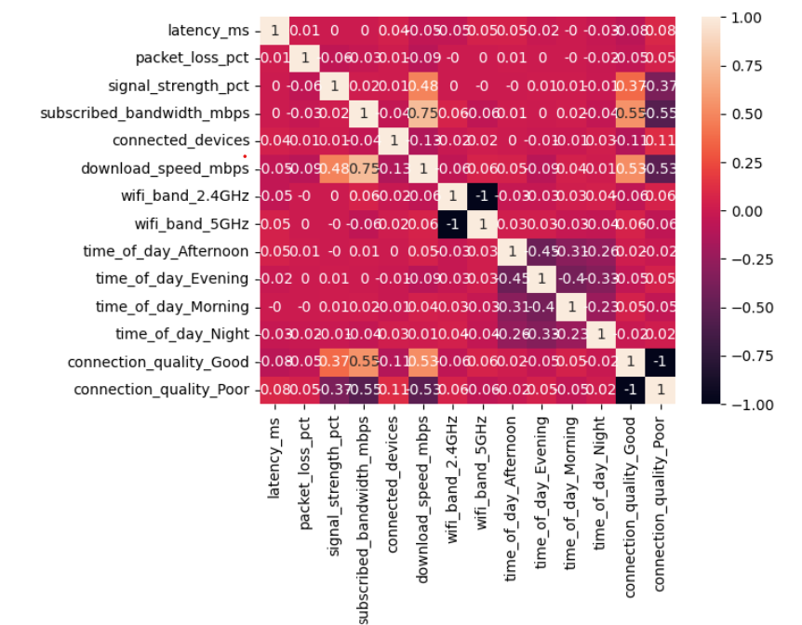
Feature | Correlation | Interpretation
Subscribed bandwidth | +0.75 | Strong positive relationship
Signal strength | +0.48 | Moderate positive relationship

Test 4: Checks whether observations/errors are related to previous observations like time series
Auto Regression: Passed
Test 5: Expected Homoscedasticity
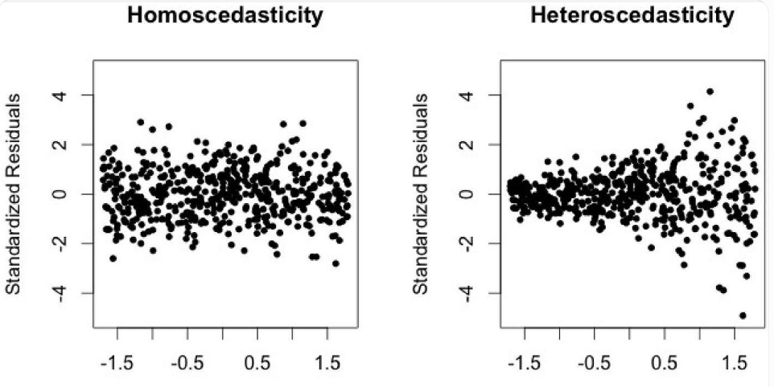
Homoscedasticity: means about the variance of residuals (errors) remaining approximately constant across different values of the independent variable. It is not about the variance of the input variable itself.
Check: If residuals have approximately equal vertical spread across latency values → supports homoscedasticity.
Homoscedasticity: failed
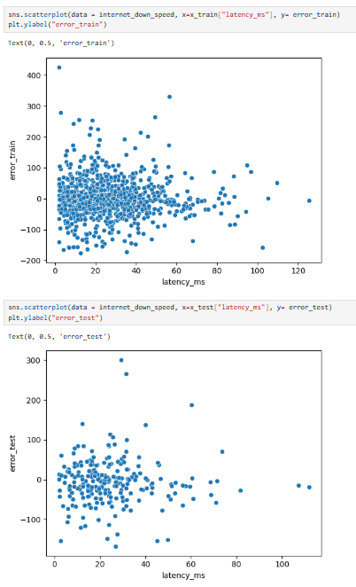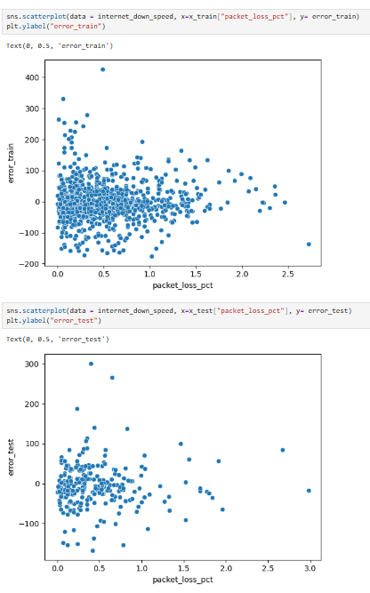

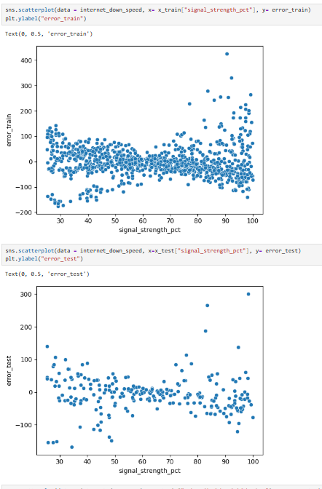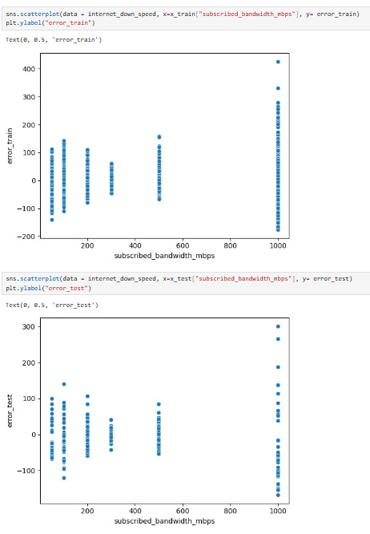

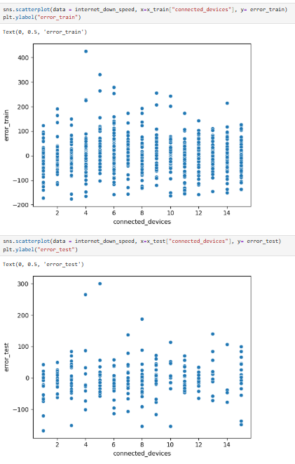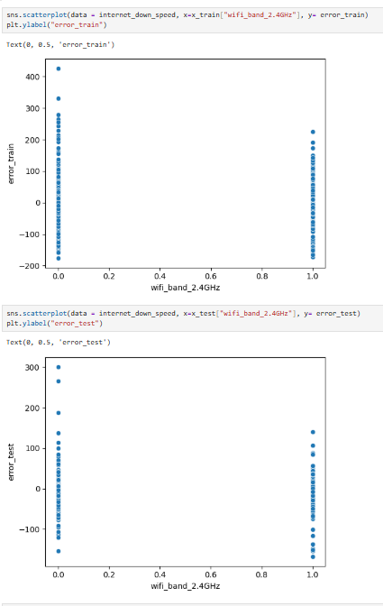

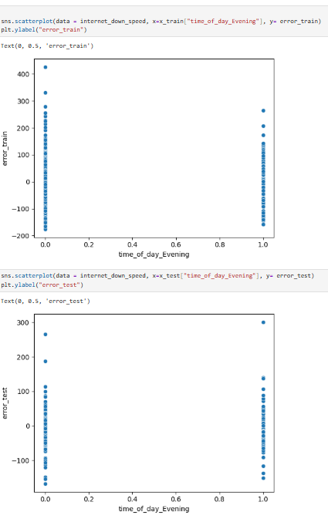

Test 6: Zero Residual test : Actual o/p Vs Predicted O/P
Expected :
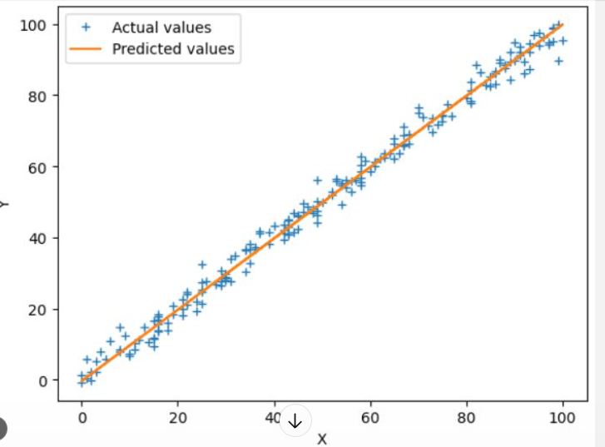

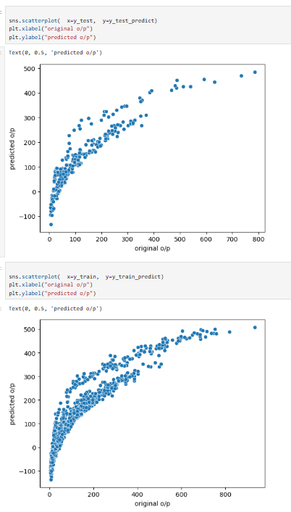

Quick Notes:
- Linearity test: to check how each input feature related to the output feature is approximately linear. A single line trend supports linearity
sns.lmplot(data=internet_speed, x=”i/p”, y=”o/p”)
- Normality test: how input features are distributed
Plt.hist(x=internet_speed[“latency”])
- Correlation matrix: to check the correlation of input feature Vs Output features
Corr_matrix = internet_speed.corr().round(2)
Sns.heatmap(corr_matrix, annot=True)
- Auto regression: Checks whether there is a dependency on the time series
- homoscedasticity: If error have approximately equal vertical spread across each i/p values
sns.scatterplot(data = internet_down_speed, x=x_train["packet_loss_pct"], y= error_train)
- Zero residual: Actual o/p Vs Predicted o/p
sns.scatterplot(x= y_train, y = y_train_predict)

Evaluation matrix:
Suppose your model predicts these download speeds:
Actual speed | Predicted speed | Absolute error
100 Mbps | 90 Mbps | 10 Mbps
200 Mbps | 170 Mbps | 30 Mbps
300 Mbps | 250 Mbps | 50 Mbps

Mean absolute error: Average error
Mean =$\frac{10+30+50}{3}=30\text{ Mbps}$
mean_absolute_error(y_train, y_train_predict)
mean_absolute_error(y_test, y_test_predict)

Squared mean error: Error magnitude, with more penalty for large errors, in Mbps
mean_squared_error(y_train, y_train_predict)
mean_squared_error(y_test, y_test_predict)

Root mean squared error: Average percentage error
root_mean_squared_error(y_test, y_test_predict)
root_mean_squared_error(y_train, y_train_predict)

R2 score – Is my input feature contributing to calculate output feature
R2 adjusted – how well my input feature contributing to calculate output feature

